**TRELLO SNAPSHOTS:**

**SNAPSHOT 1(PRODUCT BACKLOG)**

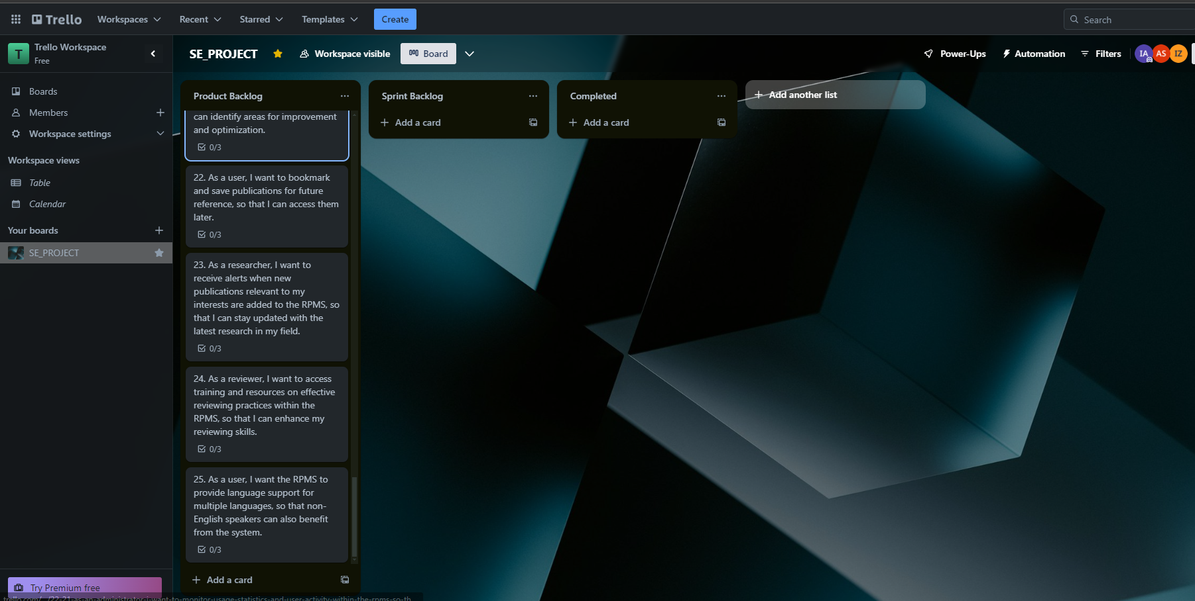

**SNAPSHOT 2(SPRINT BACKLOG - PUBLICATION SUBMISSION MODULE)**

**SNAPSHOT 3**

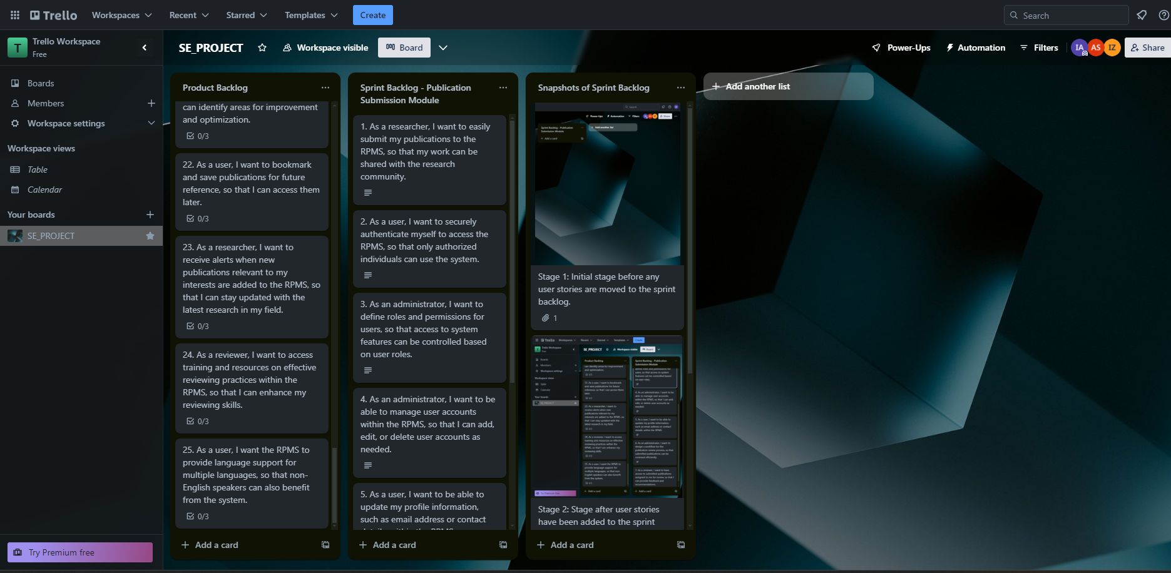

**SNAPSHOT 4**

